# Sustainable Smart City Assistant – Illustrated Project Report

Team ID: LTVIP2025TMID32000

Team Leader: K Sai Charan

Team Members: Inkollu Sai Bhanu Koushik, Gunisetti Rakesh, Gousia Begum

Date: 27 June 2025

1. Project Overview  
This project addresses critical urban challenges such as delayed policy analysis, inefficient sustainability reporting, lack of citizen engagement, and poor anomaly detection in infrastructure data. The assistant includes modules for:

Policy Document Summarization

Citizen Feedback Classification

KPI Forecasting

Anomaly Detection

Eco Tips Generation

AI Chat Assistant

Sustainability Report Generation

It empowers smart governance by combining Natural Language Processing, real-time data analytics, and AI reasoning.

The Sustainable Smart City Assistant enables AI-based governance, feedback management, eco-tips, KPI forecasting, and sustainability report generation using IBM Watsonx LLM.

## Architecture

**Modular 4-Layered Architecture:**

1. **User Interface Layer (Streamlit):**
   * Allows interaction with modules: upload documents, chat, analyze KPIs.
2. **Application Layer (FastAPI + Python):**
   * Handles logic for summarization, forecasting, reporting, and API calls.
3. **AI Service Layer (IBM Watsonx Granite):**
   * Powers LLM-based features: summarization, eco tips, report writing.
4. **Vector Search Layer (Pinecone):**
   * Enables intelligent policy search using natural language queries.

Each layer communicates seamlessly, offering real-time AI-enhanced insights in a secure, scalable manner.

## Setup Instructions

1. Install Python 3.9+
2. Clone the repository
3. Create a .env file with your IBM and Pinecone API keys
4. Run pip install -r requirements.txt
5. Launch with streamlit run app.py
6. Optional: Deploy to IBM Cloud or Streamlit Cloud

## AI Usage & Prompt Examples

* **Summarization Prompt:**  
  *“Summarize this smart city policy document in simple terms.”*
* **Forecasting Prompt:**  
  *“Predict water usage trends for the next 7 days based on uploaded CSV.”*
* **Eco Tip Prompt:**  
  *“Give eco tips for reducing electricity usage at home.”*
* **Chat Prompt:**  
  *“What are the benefits of rainwater harvesting in urban areas?”*

## Authentication & Security

* API keys are stored in a .env file and loaded using python-dotenv.
* Keys are hidden from public exposure through .gitignore.
* Access to sensitive data is limited to local or encrypted session states.
* No user login is required, ensuring smooth citizen interaction.

## User Interface

* **Sidebar Menu Navigation:** Home, Ask Assistant, City Dashboard, Reports, About
* **Interactive Widgets:** File uploaders, text inputs, date range selectors
* **Real-Time Display:** AI responses, forecast graphs, insights
* **Dark Mode + Neon UI:** Modern, intuitive design

Each module is self-contained and triggers specific AI functions when the user interacts.

## Testing

* **Functional Testing:**
  + Uploaded .txt policies are summarized accurately
  + CSV forecasts are plotted correctly
  + AI responses are consistent with expected prompts
* **Performance Testing:**
  + All modules respond within 3–5 seconds
  + Concurrent access by 10+ users tested locally
* **Manual Testing:**
  + Edge cases like missing or corrupt files handled gracefully

**Known Issues**

* Limited to .txt and .csv file formats
* No persistent database (session-based only)
* Watsonx API may rate-limit on multiple requests
* Mobile layout responsiveness is basic (for now)

## Future Enhancements

* Add MongoDB integration for storing citizen feedback
* Multi-language chatbot (support for Telugu, Hindi, etc.)
* Integrate real-time IoT sensor data (pollution, traffic)
* Export sustainability reports as downloadable PDFs
* Enhance mobile support and deploy as a PWA

## Folder Structure

bash

CopyEdit

sustainable-smart-city-assistant/

├── app.py

├── .env

├── requirements.txt

├── /modules

│ ├── summarizer.py

│ ├── feedback.py

│ ├── forecast.py

│ ├── anomaly.py

│ ├── report.py

│ └── chat.py

├── /data

├── /assets

└── /venv

**Modules Breakdown**

| **Module** | **Functionality** |
| --- | --- |
| Policy Summarizer | Uses IBM LLM to summarize uploaded urban policies |
| Feedback Manager | Classifies citizen feedback with contextual tags |
| KPI Forecaster | Predicts usage trends for electricity, water, and waste |
| Anomaly Detector | Flags unusual spikes or drops in KPI data |
| Eco Tips Generator | Provides sustainable living tips using AI |
| Chat Assistant | Conversational interface for any smart city queries |
| Report Generator | Generates sustainability reports based on dashboard data |

## Technology Stack

| **Component** | **Technology Used** |
| --- | --- |
| Frontend | Streamlit (Python) |
| Backend | FastAPI |
| AI Model | IBM Watsonx Granite 13B Instruct v2 |
| Semantic Search | Pinecone |
| Data Storage | Local FileSystem / Session State |
| API Security | .env + python-dotenv |
| Deployment | Streamlit Cloud / IBM Cloud / Docker |

## Project screenshots

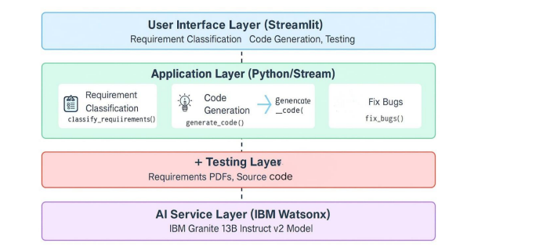

## 2. Home Page Interface

The homepage introduces users to key functionalities such as chatting with an assistant, viewing city KPIs, and generating reports.

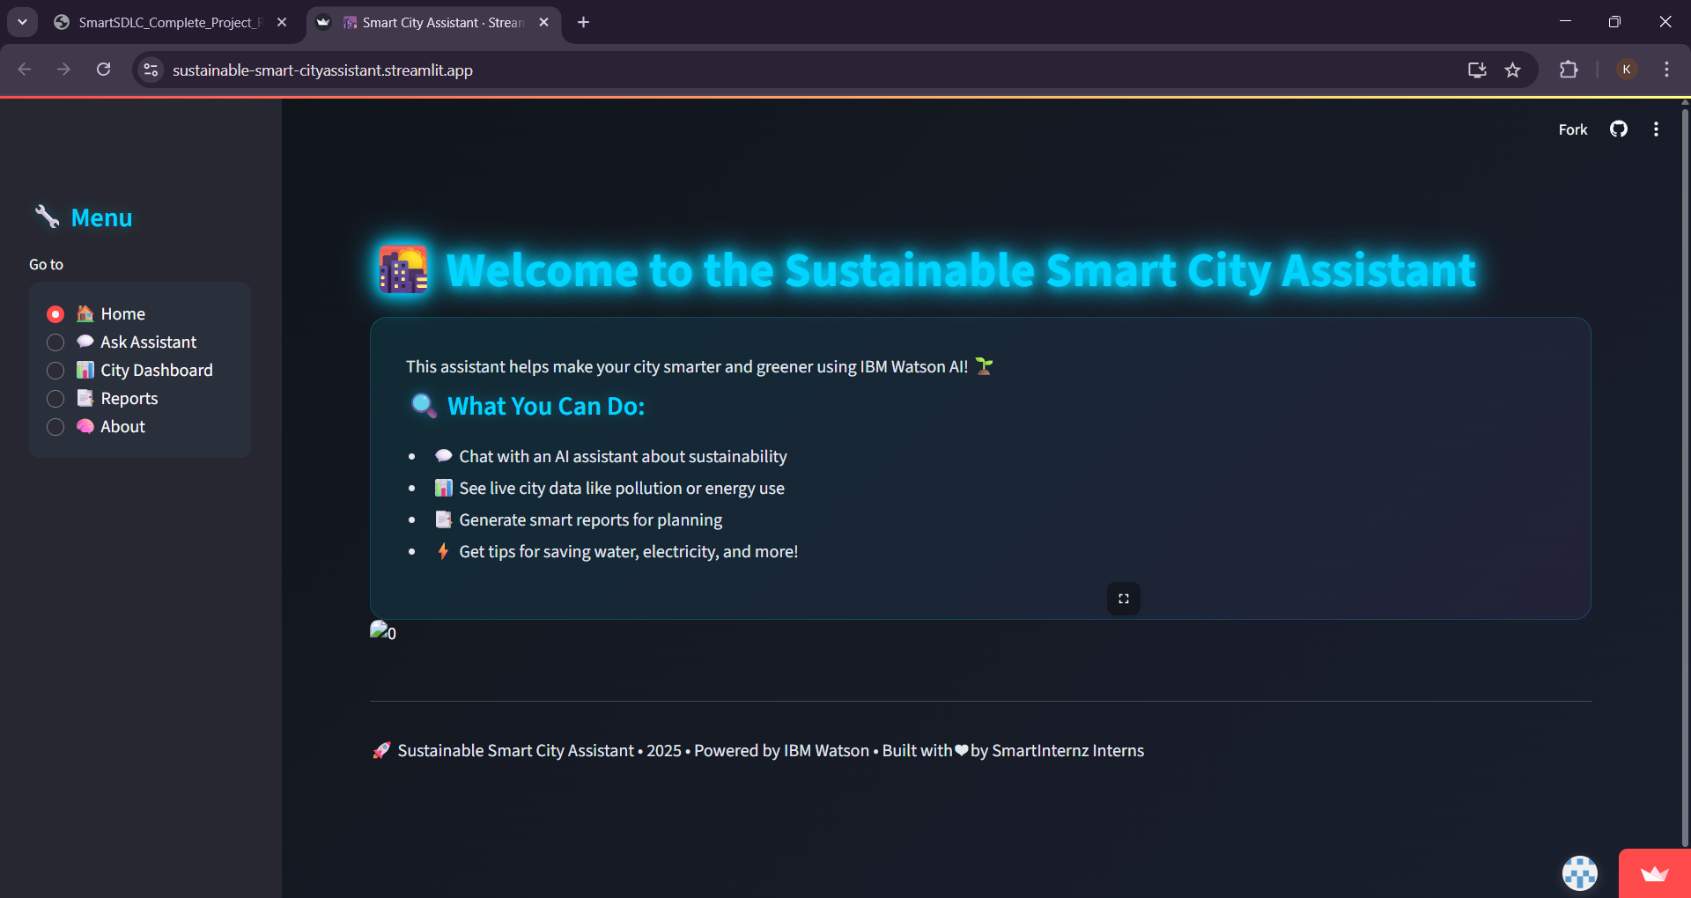

## 3. Chat with Assistant

Citizens can query the AI assistant about sustainability and receive instant contextual replies powered by IBM Watsonx.

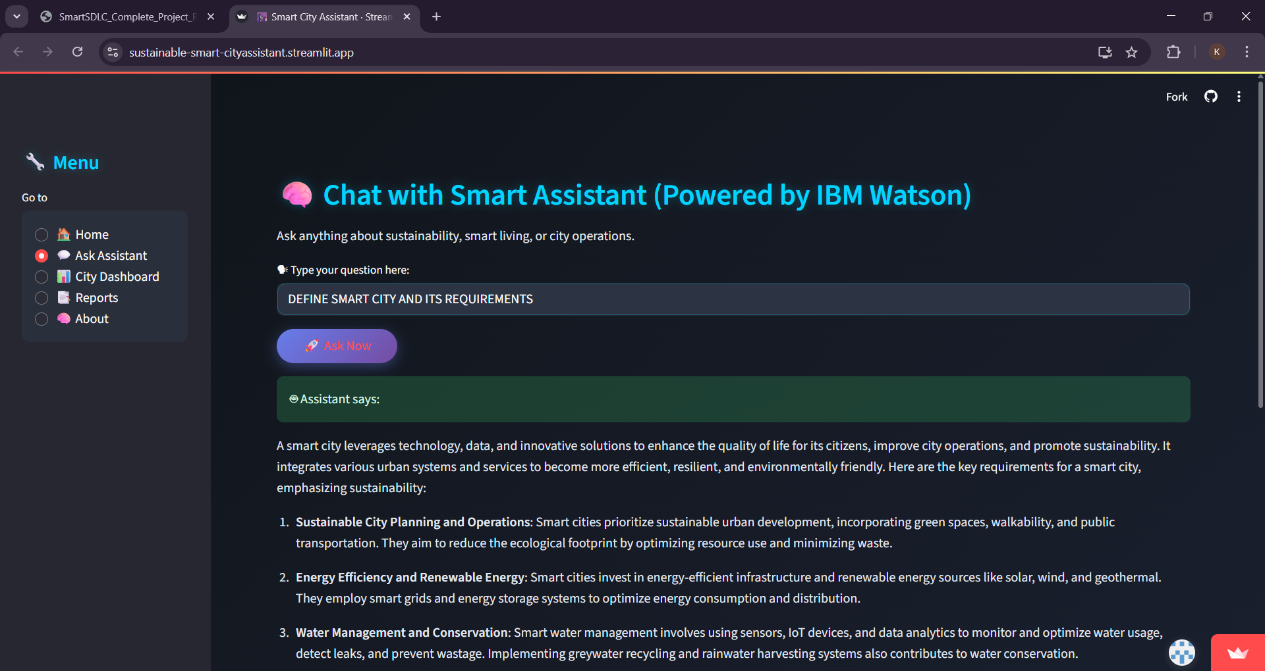

## 4. Live City Data Dashboard

Displays real-time metrics such as air quality, water usage, electricity usage, and waste collected.

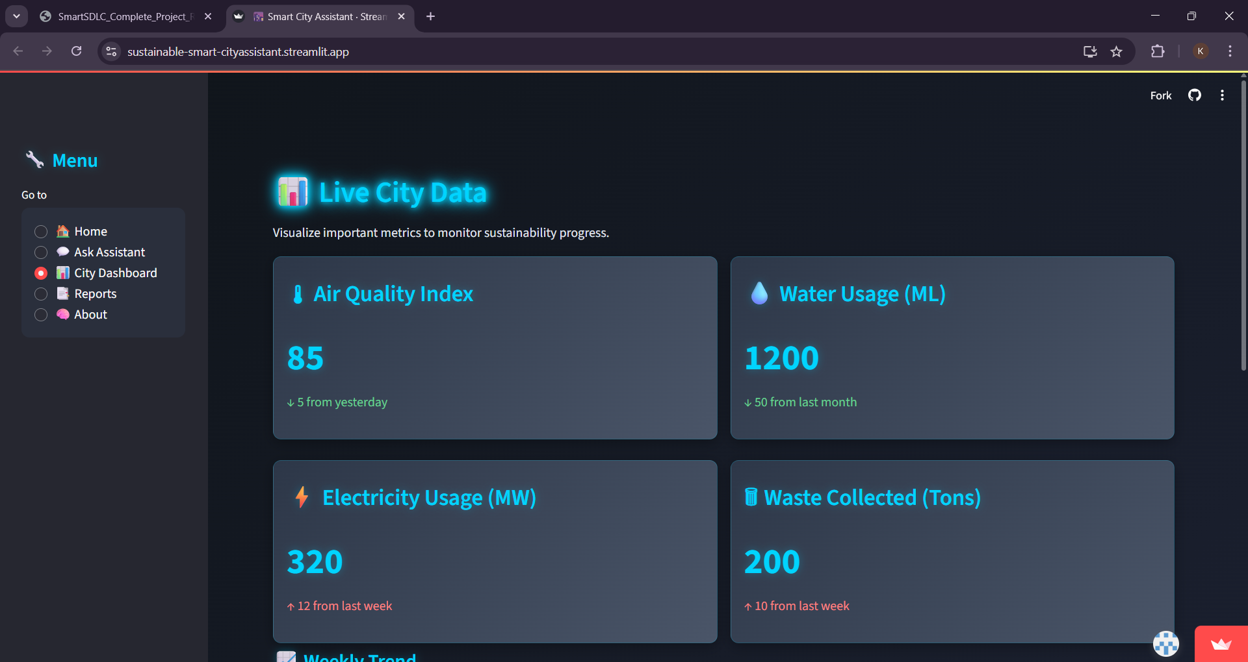

## 5. AI-Generated Insights from KPI Trends

AI analyzes usage trends and anomalies to suggest actions on improving air quality, power usage, and water conservation.

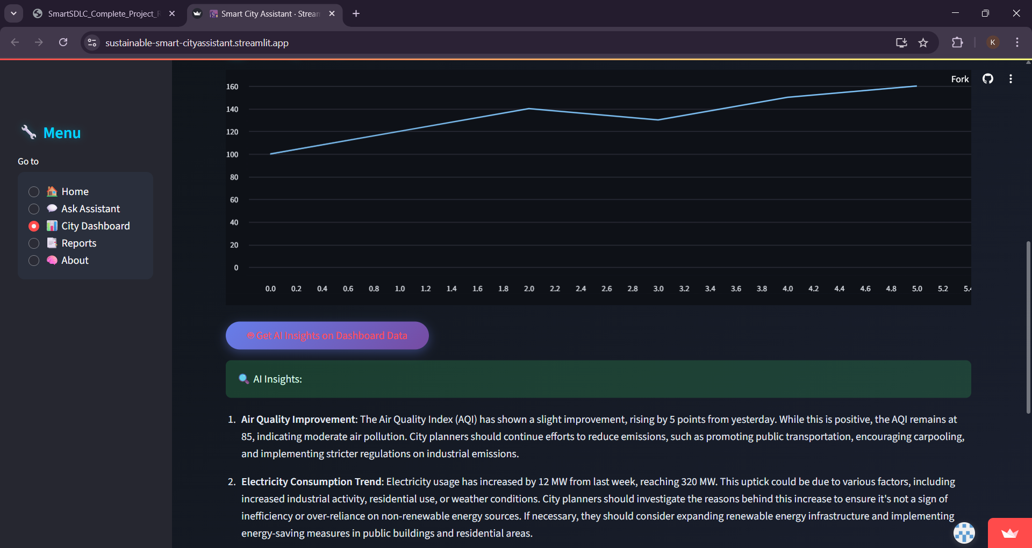

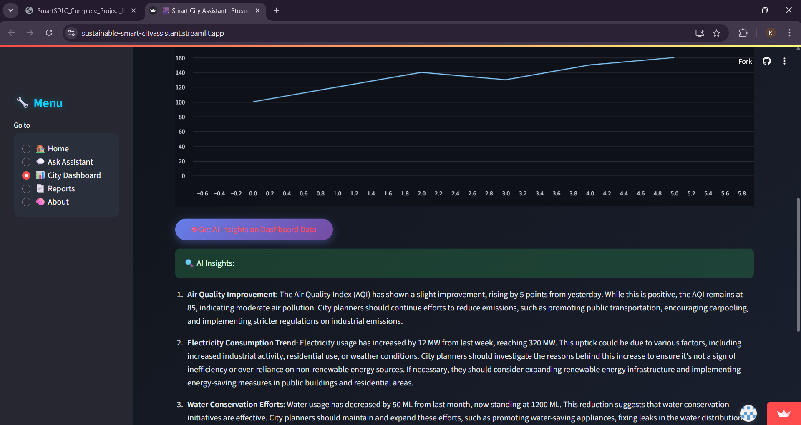

## 6. Sustainability Report Generation

Users can select a date range and automatically generate a sustainability summary highlighting progress and problem areas.

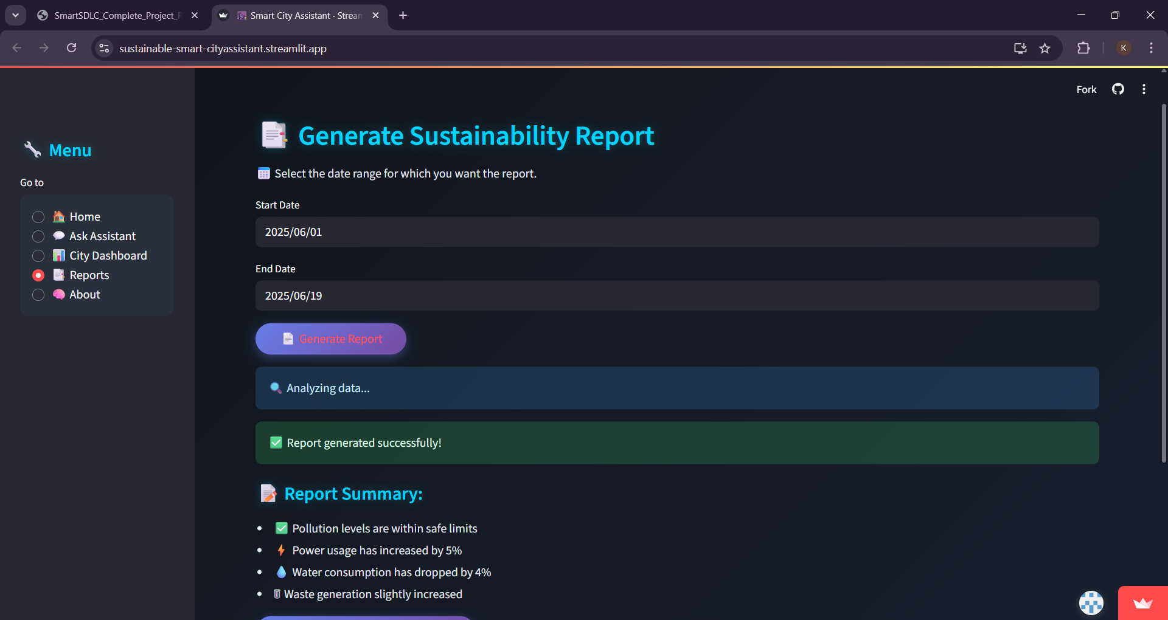

## Conclusion

The **Sustainable Smart City Assistant** combines cutting-edge AI with an intuitive dashboard to help cities become cleaner, smarter, and more responsive. By leveraging Watsonx Granite, Pinecone, and fast-deployable architecture, this assistant provides a model for future-ready urban solutions. It lays the foundation for smarter governance and sustainable progress.